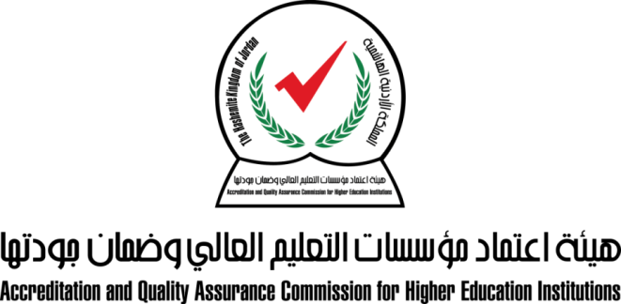
المركز الوطني للاختبارات
كفايات برنامج والتخصصات الطبية والطبية المساندة

1 - تخصص الطب - Basic
Biostatistics
Anatomy
Biochemistry
genetics
Pharmacology
Microbiology
Pathology
Physiology

2 - تخصص طب وجراحة الأسنان
علوم طب الأسنان الأساسية
علوم طب الأسنان السريرية
العلوم الطبية الحيوية الأساسية
العلوم الطبية السريرية

3 - تخصص دكتور الصيدلة
Therapy and pharmacy practice
Basic Science medical/pharmaceutical
Social and Administrative, research outcomes
Pharmacology/Therapeutics
Knowledge of dosage forms and its preparation and manufacturing methods

4 - تخصص الصيدلة
Basic knowledge in classes, mechanisms of action, therapeutic indications and side effects of medications
Biopharmaceutics, pharmacokinetics and drug metabolism
Clinical Pharmacy and Pharmacotherapy
Knowledge of dosage forms and its preparation and manufacturing methods
Pharmacy Practice and its relevant topics
Understanding the essentials of pharmaceutical analysis and quality requirements

5 - تخصص التمريض
تمريض صحة البالغين (باطني وجراحي)
الأمومة والطفولة
تمريض صحة المجتمع والإدارة والقيادة، التثقيف الصحي و تمريض الصحة النفسسية والاتصال والتواصل العلاجي والبحث العلمي

6 - تخصص علوم السمع والنطق
Assessment and intervention of articulation & phonology
Assessment and intervention of language and language disorders
Assessment and intervention of fluency Disorders
Assessment and intervention of voice disorders
Assessment and intervention of neurological based communicative disorders
Assessment and intervention of swallowing disorders/ dysphagia
Assessment and intervention of hearing and hearing disorders

7 - تخصص العلاج الوظيفي
Basic skill in occupational therapy
Pediatric occupational therapy
Occupational therapy for physical dysfunction(physical dysfunction, Neurological occupational therapy and upper limp rehabilitation )
Occupational therapy for psychological disorders, Geriatric occupational therapy and community based rehabilitation.

8 - تخصص العلاج الطبيعي (الفيزيائي)
Cardiorespiratory basic/ clinical/ practical competencies
Neuromuscular basic/clinical / practical competencies.
Musculoskeletal basic/clinical / practical competencies.
paediatrics basic/clinical / practical competencies
special population- basic/clinical / practical competencies.
principles of rehabilitation/ basic/clinical / practical competencies
research and measurement – basic/clinical / practical competencies

9 - تخصص الأشعة (تكنولوجيا الأشعة)
Anatomy (for radiographers)
Patient care, preparation, assessment, and education
Radiographic procedures
Image quality

10 - تخصص المختبرات الطبية
knowledge of safety, bio-risk management, and critical laboratory values
skills in reception, proper handling of specimens, and basic laboratory skills
knowledge and skills in of hematology laboratory medicin
knowledge and skills in of blood banking, and transfusion medicin
knowledge and skills of clinical chemistry
knowledge and skills of serology, immunology, and molecular biology techniques
knowledge and skills of microbiology, urine examination, and stool examination

11 - تخصص البصريات والسمعيات (علم البصريات)
Cornea and contact lenses
Ocular diseases and special testing
Ophthalmic lenses and dispensing
Orthoptics and low vision
Refraction and routine eye examination

12 - تخصص الإسعاف والطوارئ
knowledge and skills of airway management
knowledge and skills of skin and musculoskeletal system
knowledge and skills of pharmacology and drugs in emergencies
knowledge and skills of neonatal emergencies
knowledge and skills of trauma
knowledge and skills of Cardiopulmonary resuscitation
knowledge and skills about different aspect of cardiology emergency medicine
knowledge and skills in Shock
knowledge and skills of Obstetrics and gynecology emergencies
knowledge and skills of Toxicology emergencies
knowledge and skills of endocrine emergencies
knowledge and skills of gastrointestinal and renal systems emergencies
knowledge and skills of gastrointestinal and renal systems emergencies
knowledge and skills of pediatric emergencies

13 - تخصص الطب البيطري
knowledge and skills of large animal (Food animal) Medicine, infectious diseases, and surgery
knowledge and skills of Poultry diseases and Poultry management
knowledge and skills of general Laboratory procedure, sample handling and requirements
knowledge and skills of small animal medicine, infectious disease, and surgery
knowledge and skills of food hygiene
knowledge and skills of theriogenology (Animal reproduction)

14 - تخصص علوم طب الأسنان المساندة

Basic Sciences in Dental Technology
Removable Prosthodontics
Fixed Prosthodontics
Dental Implantology
Maxillofacial Prosthodontics

15 - تخصص الأطراف الإصطناعية والأجهزة المساندة
Safety and basic skills
Basic skills of casting and plaster works
Plastic works
Patient care
Lower limb prostheses
upper limb prosthesis
lower limb orthoses
upper limb orthoses
Basic functional anatomy and biomechanics
Principles of Amputations and amputee Rehabilitation
Metal work
Spinal orthoses

16 - تخصص القبالة
ethics in midwifery
antenatal care
labor and childbirth care
newborn care
postnatal care
women's' health care

17 - تخصص الأحياء الدقيقة
Human physiology, Histology and Immunology
Molecular and cell biology, microbial genetics
Biochemistry and Metabolism
General Microbiology (bacteriology, mycology, virology and parasitology)
Applied Microbiology (Industrial, medical, environmental and diagnostic microbiology)

18 - تخصص الإدارة والسياسات الصحية
ادارة الرعاية الصحية
تنظيم وتمويل الرعاية الصحية
ادارة الموارد الصحية
العلوم السلوكية
نظم المعلومات الصحية والديموغرافية
المجالات المساندة

19 - تخصص تكنولوجيا صناعة الأسنان

Basic Sciences in Dental Technology
Removable Prosthodontics
Fixed Prosthodontics
Dental Implantology
Maxillofacial Prosthodontics

